Project 1 task 2-

**I.**

**1. Write a mapreduce program to remove commas present inside the double quotes**.

**CODE-**

**DRIVER**-

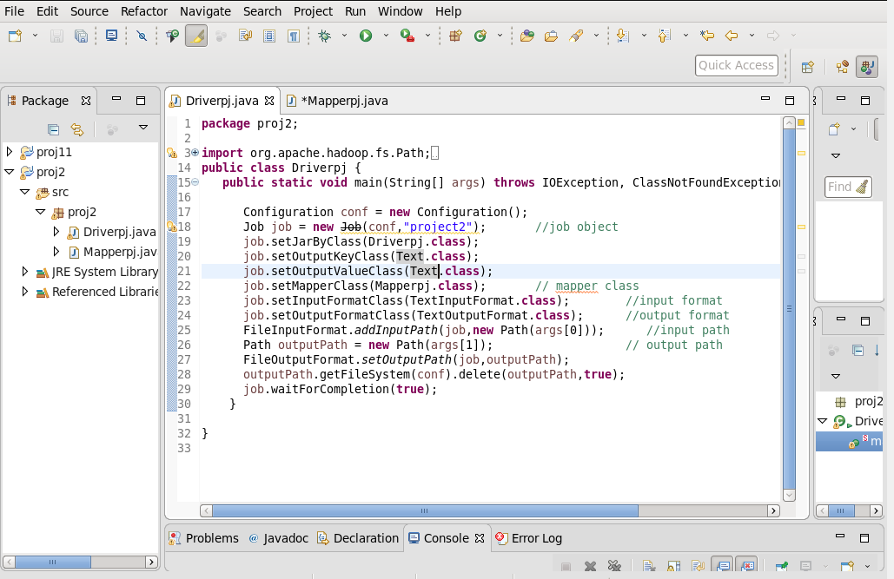

**MAPPER-**

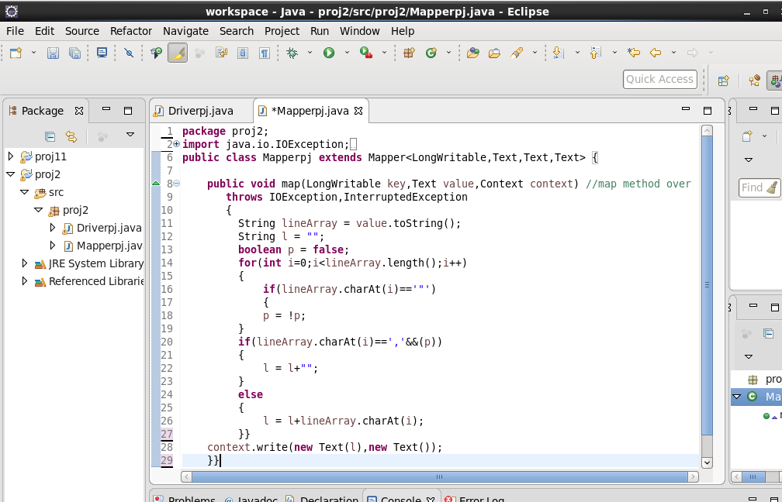

**COMMAND-**

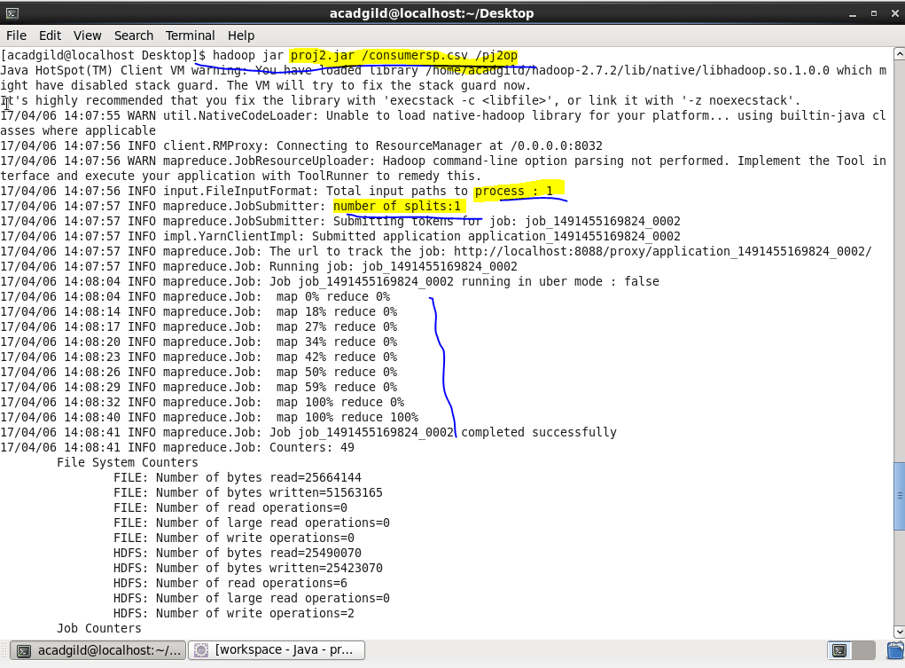

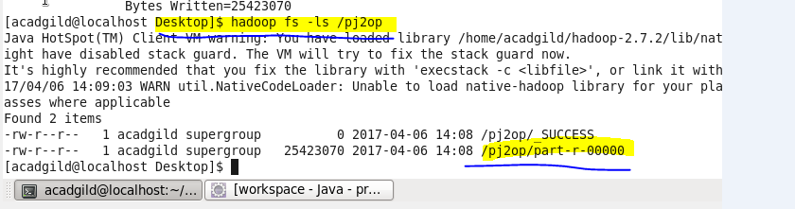

**OUTPUT-**

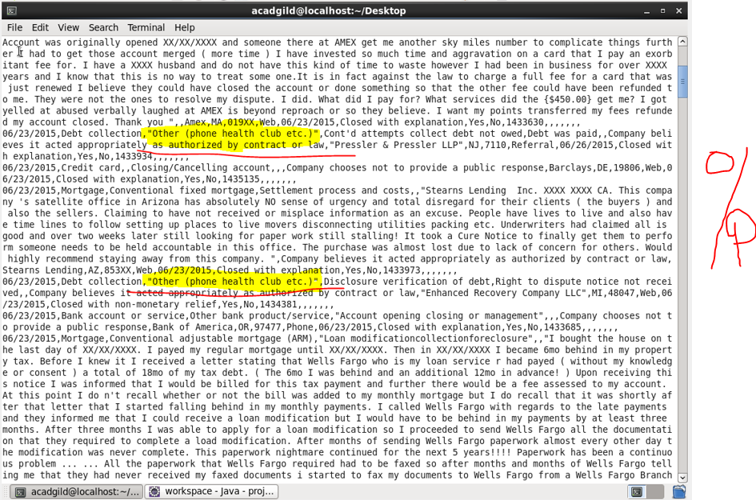

**GET COMMAND TO USE FILE IN PIG-**

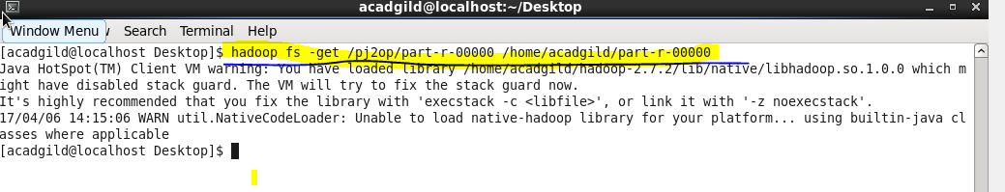

**II.**

1. **Write a pig script to find no of complaints which got timely response**

**COMMANDS-**

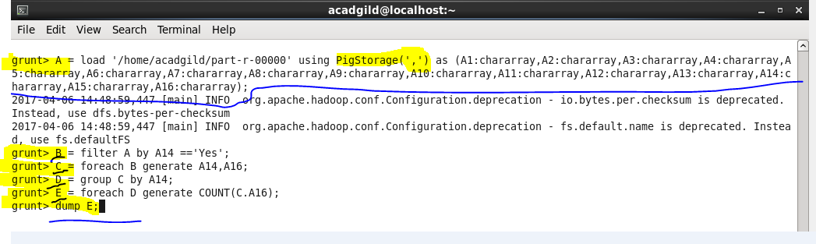

**OUTPUT-**

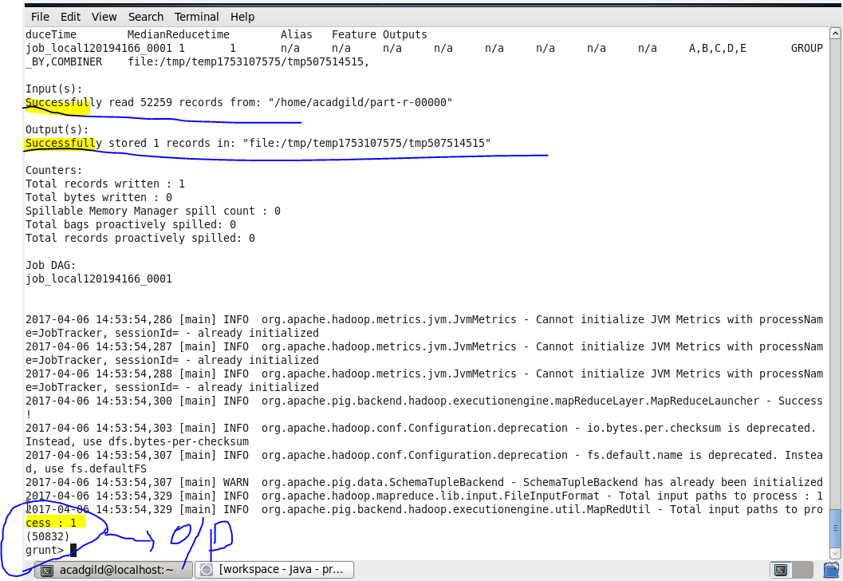

1. **Write a pig script to find no of complaints where consumer forum forwarded the complaint same day they received to respective company**

**COMMANDS-**

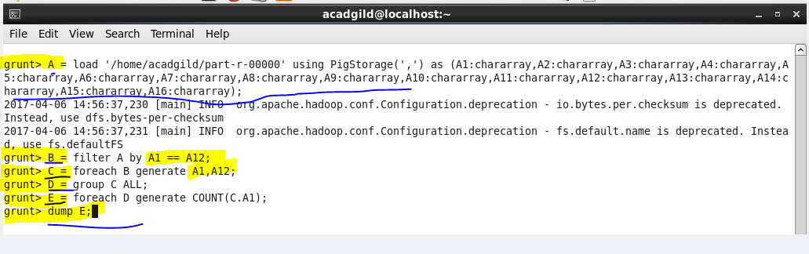

**OUTPUT-**

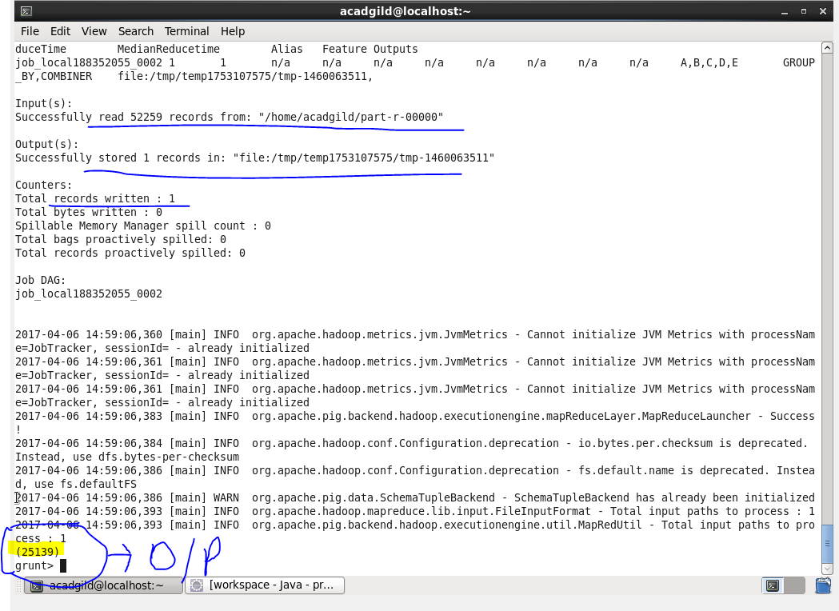

1. **Write a pig script to find list of companies topping in complaint chart (companies with maximum number of complaints)**

**COMMANDS-**

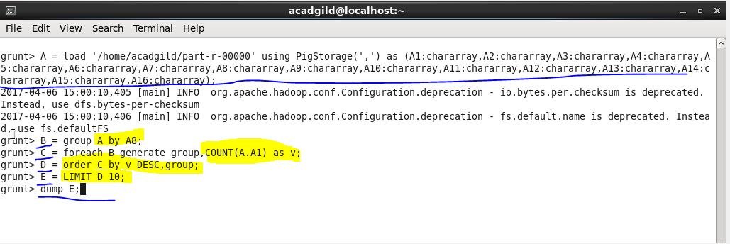

**OUTPUT-**

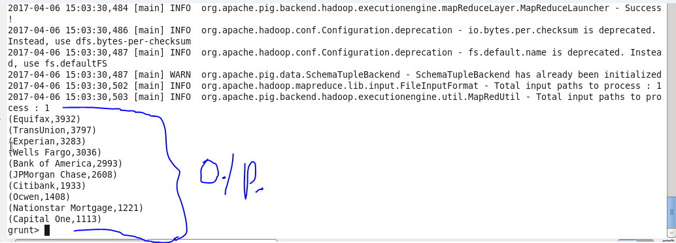

Company named as Equifax having maximum number of complaint and is at top of list and Capital One has minimum number of complaint and it is at bottom.

1. **Write a pig script to find no of complaints filed with product type has "Debt collection" for the year 2015**

**COMMANDS-**

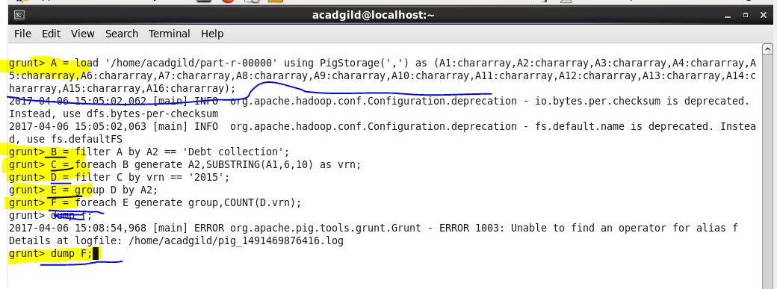

**OUTPUT-**

